A SOC Mini Project

Report

On

VOTING AND TICKETS BOOKING FOR AWARD SHOW



**Submitted**

**By**

**Ch.Sudharshan RegNo:20B91A0550**

**DEPARTMENT OF COMPUTER SCIENCE ENGINEERING**

**S.R.K.R ENGINEERING COLLEGE(A)**

**(Affiliated to JNTU ,KAKINADA)**

**BHIMAVARAM-534204**

**(2020-2021)**

**DEPARTMENT OF COMPUTER SCIENCE AND ENGINEERING**

# S.R.K.R.ENGINEERING COLLEGE BHIMAVARAM



# *CERTIFICATE*

This is to certify that this is a bonafide work on “**Voting and Tickets booking for Show**” and has been submitted by Mr.Ch.Sudharshan (20B91A0550) in partial fulfilment of the requirements for the award of the Degree of Bachelor of Technology in Computer Science and Engineering ,during the academic year2021-2022.The candidate worked right under my Super vision and guidance.

| **Lecturers In-Charge** | **Head of the Department** |
| --- | --- |
| Sri.K Durga Venkata Pavan Kumar Varma | **Dr.V.Chandra Sekhar** |
| Assistant professor, | Head of the Department, |
| Department of CSE, | Department of CSE, |
| S.R.K.R. Engineering College, | S.R.K.R. Engineering College, |
| Bhimavaram | Bhimavaram. |
|  |  |

## ACKNOWLEDGEMENT

I take immense pleasure in thanking **Dr.M. Jagapathi Raju,** beloved principal of S.R.K.R Engineering College , Bhimavaram and **Dr.V. ChandraSekhar**, esteemed Head of the Department(C.S.E),for having permitted me to carry out this software engineering mini project work.

I wish to express my deep sense of gratitude specially to my project Guide ,**Sri.K D V P K VARMA** Assistant Professor ,for his able guidance and useful suggestions , which helped me in completing the project work ,in time.

Needless to mention that **Sri.K D V P K VARMA** , Assistant Professor, for his timely guidance in the conduct of my project work .Besides ,this project made me realize the value of working together as a team and as a new experience in the working environment , which challenges me every minute.

Finally, yet importantly, I would like to express my heartfull thanks to my beloved parents for their blessings ,my friends/classmates for their help and wishes for the successful completion of this project .

Ch. Sudharshan

(20B91A0550)

## TABLE OF CONTENTS

S.No CONTENTS PageNo

1 ABSTRACT

2 MODULES

3. SOFTWAREREQUIREMENTS

4. HARDWAREREQUIREMENTS

5. TECHNICALSTACK

6. SAMPLECODE

7. SCREENSHOTS

8. LABPROGRAMS

**1.ABSTRACT**

The project is on music award show related website. Present days music has been part of our daily life and a relief factor for everyone .This Award show is to appreciate those artists who are making wonderful music for our relief .This Award website help people to vote their artist to win awards and also to book tickets for the show to watch the performances of great artists.

**2 . MODULES**

* Home page
* Login page
* Voting pages
* Tickets page
* Buying page

**3.SOFTWARE REQUIREMENTS**

1. Web Browser : Google /Internet Explorer /Mozilla Firefox
2. Front End : Html
3. Text Editor : Notepad

**4.HARDWARE REQUREMENTS**

1. Processor – Intel Core i3 or above
2. RAM – 4G

**5.SAMPLE PROGRAMS**

**1.MAINPAGE**

<html>

<head>

<title>Frames</title>

</head>

<frameset rows="12%,6%,*" border="1">

<frame src="head.html" scrolling="no"></frame>

<frame src="anch2.html" scrolling="no"></frame>

<frameset cols="8%,92%">

<frame src="anchama.html" scrolling="no"></frame>

<frame src="contentama.html"name="contentarea2"></frame>

</frameset>

</html>

**2.LOGIN PAGE**

<html>

<head>

<title>LOGIN</title>

</head>

<center><h1><font color="brown" face="Lucida Bright" size="5">Login page</h1></font>

<body bgcolor="#DBAFEC">

<p>Enter your EMAIL-ID <input type="email"></p>

<p>Enter your PASSWORD <input type="password"></p>

<input type="SUBMIT">

<br>

<p><a href="Newuser.html" target="contentarea2"><font color="black"><b>NEWUSER</font></a></p>

</br>

</body>

</html>

🡪For New-user

<html>

<head>

<title>create Gmail</title>

</head>

<center><h1><font color="brown" face="Lucida Bright" size="5">Create account</h1></font>

<body bgcolor="#DBAFEC">

<p>Enter your firstname <input type="name"></p>

<p>Enter your lastname <input type="name"></p>

<p>Enter your EMAIL-ID <input type="email"></p>

<p>Enter your PASSWORD <input type="password"></p>

<input type="SUBMIT">

<a href="Newuser.html" target="contentarea2">

</body>

</html>

**3.CONTENT PAGE**

<html>

<head>

<title>contentama</title>

</head>

<body bgcolor="#55ACEC">

<center><table border="0">

<tr>

<td><img src="Grammy.jpeg" height="300" width="350" align="center"></td>

<tr>

</table></center>

<P>The Grammy Award (stylized as GRAMMY, originally called Gramophone Award), or just Grammy, is an award presented by the Recording Academy to recognize achievement in the music industry of the United States. The trophy depicts a gilded gramophone. The Grammys are the first of the Big Three networks' major music awards held annually (before the Billboard Music Awards in Summer, and the American Music Awards in Fall). The Grammy is considered one of the four major annual American entertainment awards, along with the Academy Awards (for film achievements), the Emmy Awards (for television achievements), and the Tony Awards (for theater and Broadway achievements).

The annual award ceremony features performances by prominent artists and presentation of awards that showcase achievements made by industry recording artists. The first Grammy Awards ceremony was held on May 4, 1959, to honor the musical accomplishments of performers for the year 1958. After the 2011 ceremony, the Academy overhauled many Grammy Award categories for 2012. The 63rd Annual Grammy Awards were held on March 14, 2021 (after it was postponed from its original January 31, 2021 date due to the impact of the COVID-19 pandemic on the music industry), in and around the Los Angeles Convention Center. The 64th Annual Grammy Awards will be held on January 31, 2022 at the Staples Center in Los Angeles.</p>

<a href="soloartist.html" target="contentarea"></a>

<a href="band.html" target="contentarea"></a>

<a href="female.html" target="contentarea"></a>

<a href="song.html" target="contentarea"></a>

</body>

</html>

**4.VOTING PAGES**

**🡪**Solo Artist

<html>

<head>

<title>Artist of year</title>

<body bgcolor="#BFC4F5">

<marquee behaviour="scroll" direction="left"><h1><font color="brown" face="Lucida Bright" size="5">ARTIST OF YEAR<h1></marquee>

<center><table border="2">

<tr>

<td>S.NO</td>

<td>Arstist</td>

<td>song</td>

<td>vote</td>

</tr>

<tr>

<td>1</td>

<td><ul type="circle">

<li>Justin biebar</li>

<li><img src="justin.jpeg" height="300" width="350"></li>

</td>

<td>sorry</td>

<td><button>vote</button></td>

</tr>

<tr>

<td>2</td>

<td><ul type="circle">

<li>Shawn mendes</li>

<li><img src="shawn.jpeg" height="300" width="350"></li>

</td>

<td>never be alone</td>

<td><button>vote</button></td>

</tr>

<tr>

<td>3</td>

<td><ul type="circle">

<li>Charlie puth</li>

<li><img src="charlie.jpeg" height="300" width="350"></li>

</td>

<td>see you again</td>

<td><button>vote</button></td>

</tr>

<tr>

<td>4</td>

<td><ul type="circle">

<li>zayn</li>

<li><img src="zayn1.jpeg" height="300" width="330"></li>

</td>

<td>dusk till dawn</td>

<td><button>vote</button></td>

</tr>

<tr>

<td>5</td>

<td><ul type="circle">

<li>Ed-shreen</li>

<li><img src="ed.jpeg" height="300" width="350"></li>

</td>

<td>Perfect</td>

<td><button>vote</button></td>

</tr>

</body>

</html>

**🡪**Band

<html>

<head>

<title>Band</title>

<body bgcolor="#E6CDF0">

<marquee behaviour="scroll" direction="left"><h1><font color="brown" face="Lucida Bright" size="5">ARTIST BAND OF YEAR</h1></marquee>

<center><table border="1">

<tr>

<td>S.NO</td>

<td>Arstist</td>

<td>song</td>

<td>vote</td>

</tr>

<tr>

<td>1</td>

<td><ul type="circle">

<li>IMAGINE DRAGON</li>

<li><img src="imagine.jpeg" height="300" width="350"></li>

</td>

<td>Beleiver</td>

<td><button>vote</button></td>

</tr>

<tr>

<td>2</td>

<td><ul type="circle">

<li>BTS</li>

<li><img src="bts.jpeg" height="300" width="350"></li>

</td>

<td>Dynamite</td>

<td><button>vote</button></td>

</tr>

<tr>

<td>3</td>

<td><ul type="circle">

<li>One Direction</li>

<li><img src="one.jpeg" height="300" width="350"></li>

</td>

<td>story of my life</td>

<td><button>vote</button></td>

</tr>

<tr>

<td>4</td>

<td><ul type="circle">

<li>Maroon 5</li>

<li><img src="Maroon.jpeg" height="300" width="350"></li>

</td>

<td>Memories</td>

<td><button>vote</button></td>

</tr>

</body>

</html>

**5.TICKETS BOOKING**

<html>

<head>

<title>Tickets</title>

</head>

<body bgcolor="#DBAFEC">

<center><h1><font color="brown" face="Lucida Bright" size="5">Tickets booking</h1></font>

<form>

<p>Name:<input type="text" placeholder="enter your name"></p>

<p>date of birth:<input type="date"></p>

<p>country

<select id="country" name="country">

<option value="INDIA">INDIA</option>

<option value="Australia">Australia</option>

<option value="UK">UK</option>

<option value="America">America</option>

<option value="France">France</option></select></p>

<p>phone number<input type="tel"></p>

<p>E-mail:<input type="email"></p>

<p>Select SeatOrder and Price:<select>

<option>Diamond-Rs.1500/-</option>

<option>Gold-Rs.1000/-</option>

<option>Silver-Rs.750/-</option>

<option>General-Rs.500/-</option>

</select></p>

<br>

<p><a href="booked.html" target="contentarea2"><font color="black"><b>BOOK</font></a></p>

</br>

</body>

</html>

**6.ANCHOR Page**

<html>

<head>

<title>anchor</title>

</head>

<body bgcolor="#43302E">

<a href="soloartist.html" target="contentarea2"><font color="white">solo</font></a><br>

<a href="band.html" target="contentarea2"><font color="white">band</font></a><br>

<a href="female.html" target="contentarea2"><font color="white">female</font></a><br>

<a href="song.html" target="contentarea2"><font color="white">song</font></a><br>

</body>

</html>

**6.SCREENSHOTS**

**1.Home page**

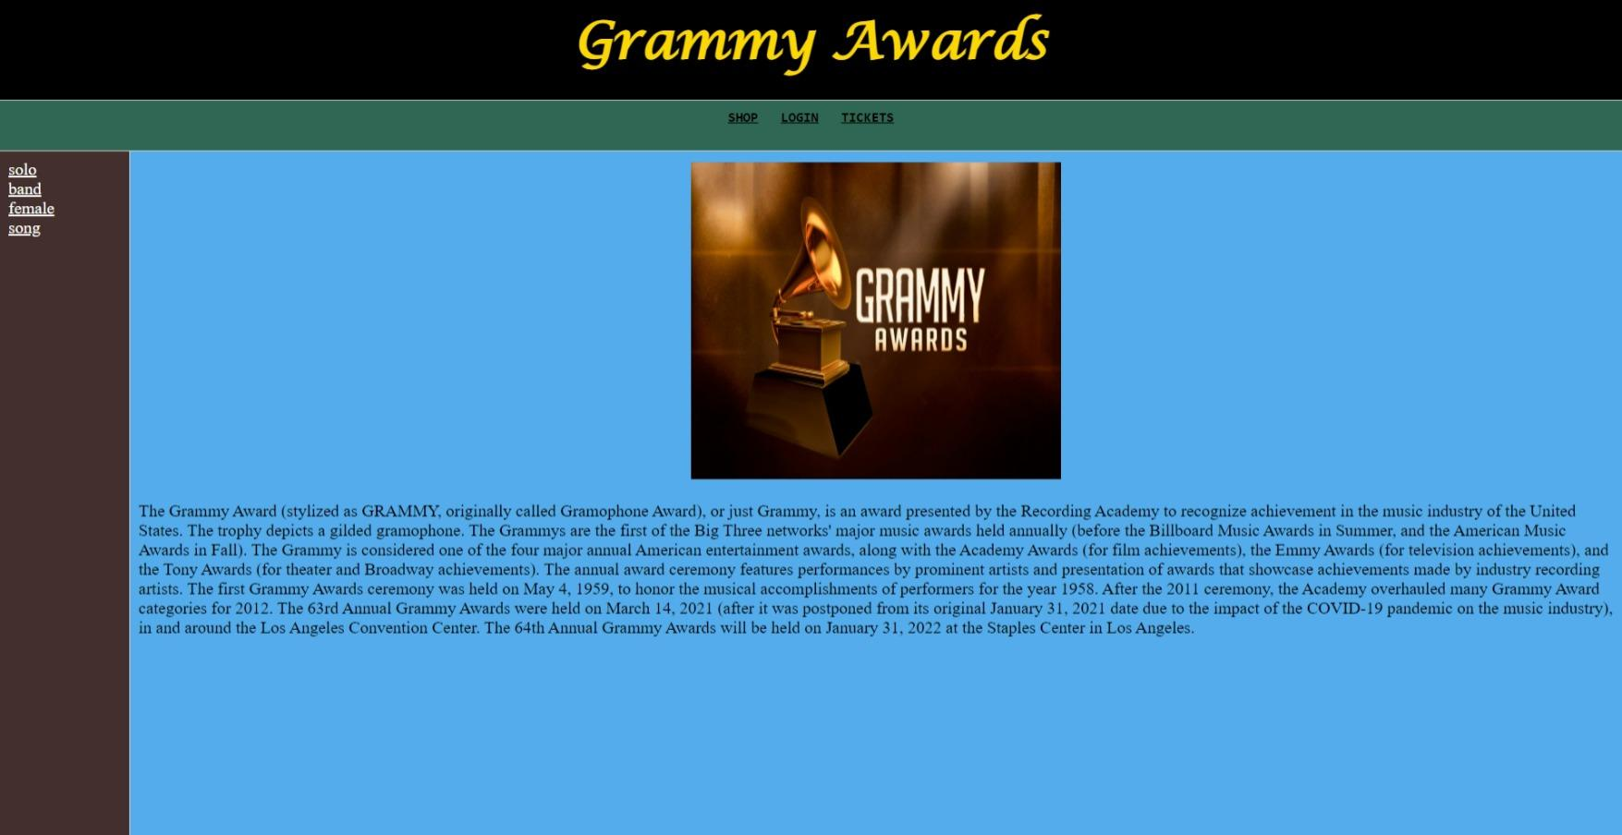

**2. Login page**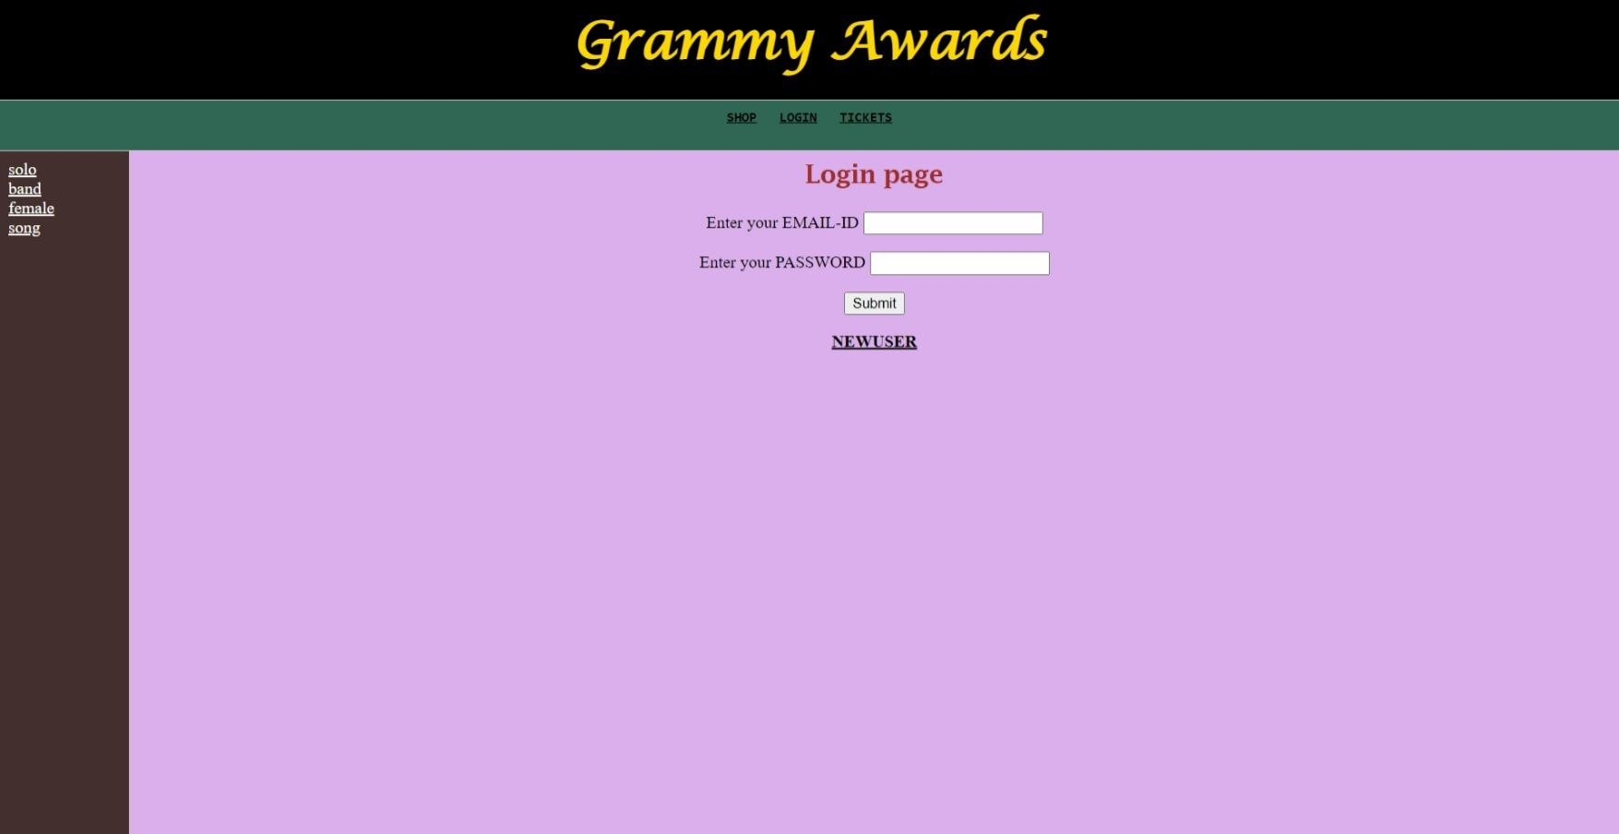

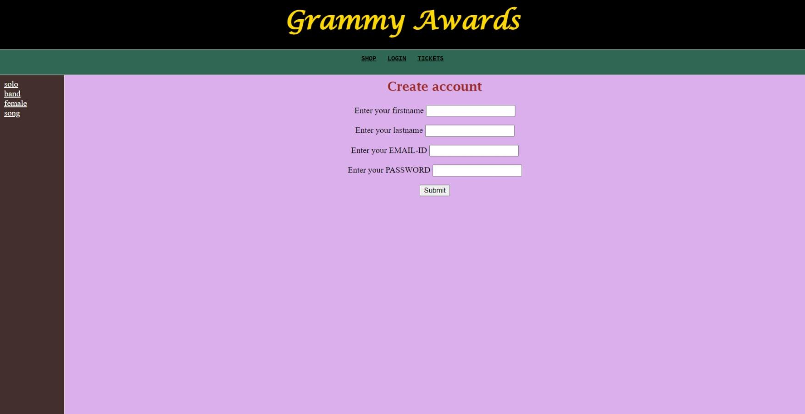

**3.VOTING**

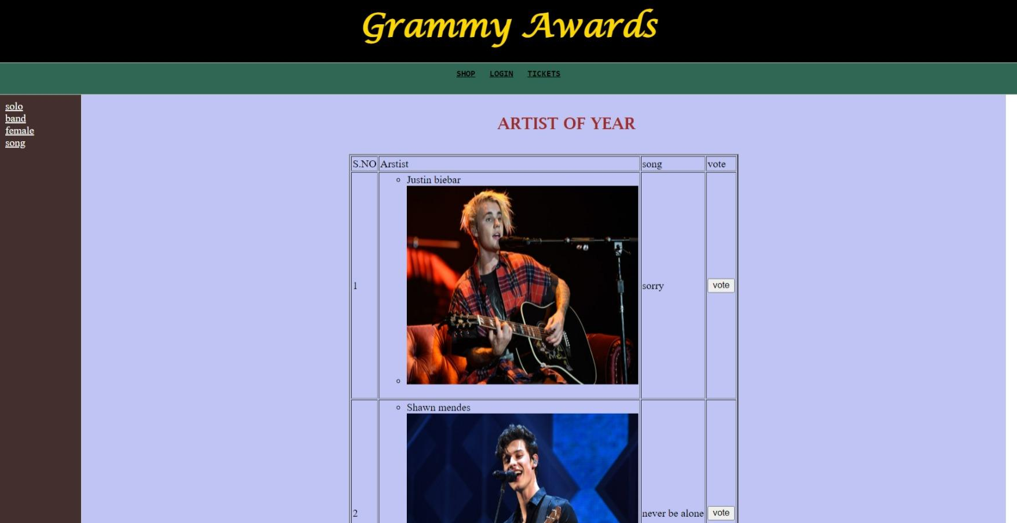

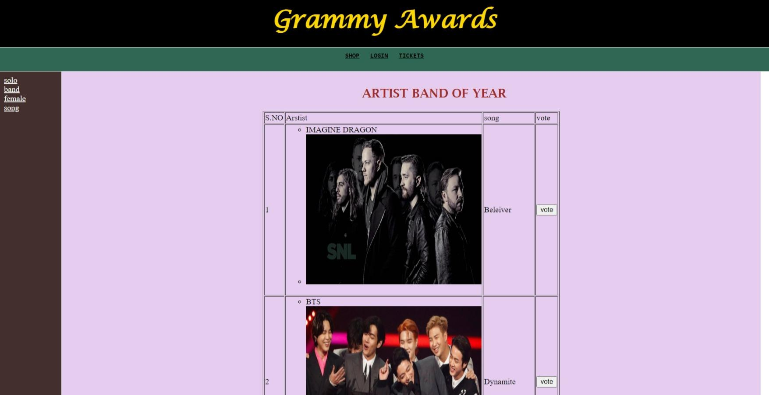

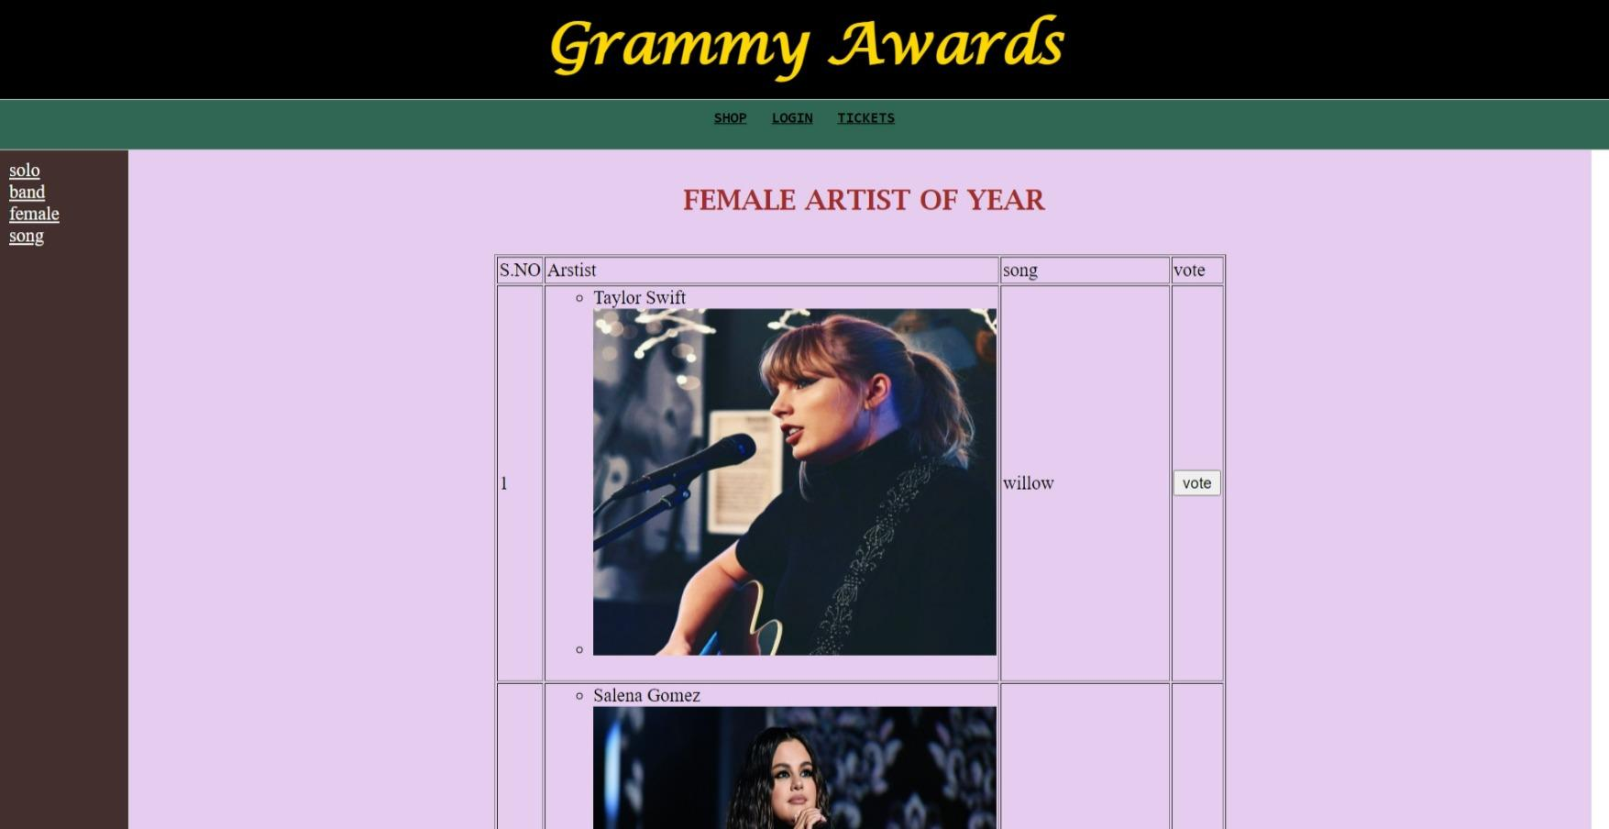

**4.TICKETS BOOKING**

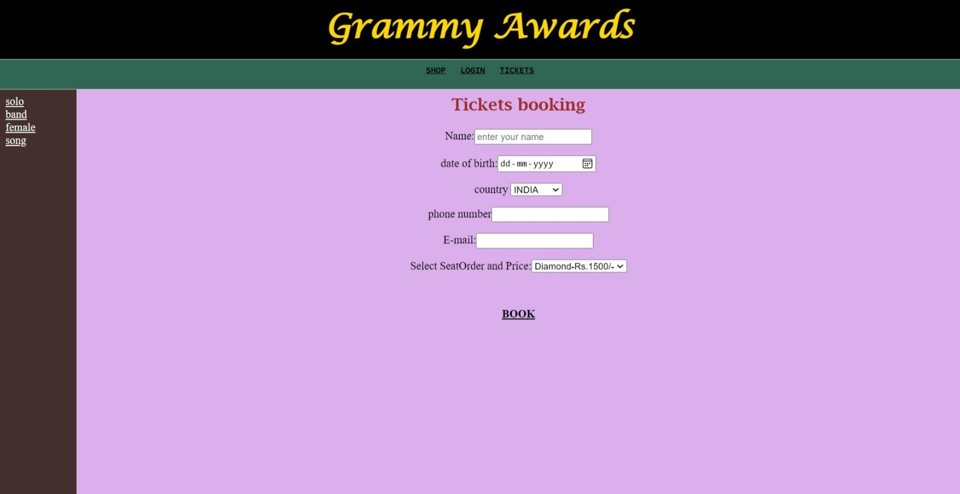

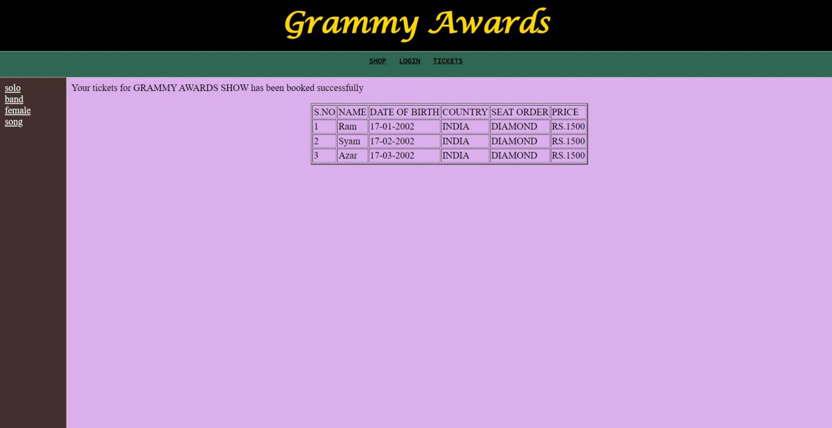

**8. LAB PROGRAMS**

**1. Write an HTML code to display your education details in a tabular format.**

<html>

<head>

<title>Education details</title>

</head>

<body>

<h1 align="center" style="color:blue">EDUCATION DETAILS</h1><br><br>

<table border="1" background="gray" cellspacing="5" cellpadding="5">

<th>SNo</th>

<th>Course</th>

<th>Board/University</th>

<th>School/College</th>

<th>Year of Passing</th>

<th>Percentage</th>

<tr>

<td>1</td>

<td>10</td>

<td>SSC</td>

<td>ST ANNS EM SCHOOL</td>

<td>2018</td>

<td>98</td>

</tr>

<tr>

<td>2</td>

<td>12</td>

<td>BIEAP</td>

<td>Sri Chaitanya Jr. College</td>

<td>2020</td>

<td>95</td>

</tr>

</table>

</body>

</html>

**2. Write an HTML code to illustrate the usage of the following:**

**Ordered List**

**Unordered List**

**Definition List**

<html>

<head>

<title> My First Page </title>

</head>

<body>

<UL type='A'>

<LI>Red

16

<LI>Blue

<LI>Green

<LI>White

</UL><br>

<OL type='square'>

<LI>Red

<LI>Blue

<LI>Green

<LI>White

</OL><br>

<dl>

<dt>Red</dt>

<dd>Red color has the highest wavelength.</dd>

<dt>Violet</dt>

<dd>Violet color has the shortest wavelength.</dd>

</body>

</html>

**3. Write an HTML code to create a Home page having three links: About Us, Our**

**Services and Contact Us. Create separate web pages for the three links.**

**About us.html**

<html>

<title> About Page </title>

<head>

</head>

<body>

<h1><center><u> ABOUT US </h1></center></u>

Interviews are crucial moments in one’s career.

Theoretical knowledge of interview questions isn't enough when you actually face an

interview.

Too often fear takes over our performance in job interviews.

As the adage goes – practice makes perfect! Mock interviews by InterviewBuddy give

you the platform to prepare,

practice and experience firsthand how a real-life job interview feels. Familiarizing

yourself with the interview

environment beforehand in a relaxed and stress-free environment gives you an edge over

your peers.

InterviewBuddy is built on the premise that practice & preparation are crucial to get over

your anxieties when attending an interview.

Our mock interviews are conducted by handpicked industry experts with an average

experience of 9+ years in the interviewing game.

So you’re sure to improve your chances of getting hired!<br>

<a href="contactus.html">CONTACT US</a><br>

<a href="services.html">SERVICES</a><br>

</body>

</html>

**Contact us.html**

<html>

<title> Contact Page </title>

<head>

</head>

<body>

<h1><center><u> CONTACT US </h1></center></u>

Contact no: +91 977885454 <br>

E-Mail : techinterview@gmail.com<br>

Address : 13-23-10/2, High Tech City , Hyderabad<br>

<a href="aboutus.html">ABOUT US</a><br>

<a href="services.html">SERVICES</a><br>

</body>

</html>

**Services.html**

<html>

<title> Services </title>

<head> </head>

<body>

<h1> <u> OUR SERVICES : </h1> </u> <br> <br>

<li>Mock Interviews</li>

<li> Personal Training</li>

<li>Study Material </li>

<li>Video courses</li>

<li>Live Classes & Doubt Clearing Session </li>

<a href="aboutus.html">ABOUT US</a><br>

<a href="contactus.html">CONTACT US</a><br>

</body>

</html>

**4. Use table tag to format web page . Also create the TimeTable of your class using**

**table class**

<html>

<head>

<title>SRKR CSE TIMETABLE</title>

</head>

<body>

<table align="center" border="1" bgcolor="white" bordercolor="black">

<tr align="center" width="10" height="20"><td colspan=9><h1>Department of

computer

science and engineering</h1></td>

</tr>

<tr align="center" width="10" height="20"><td colspan=9>SRKR

engg.college(autonomous)

(affiliated to JNTU Kakinada),chinaamiram,bhimavaram,INDIA.</td></tr>

<tr width="10" height="20"><td colspan=9 bgcolor="sky blue"></td

</tr>

<tr width="10" height="20">

<td>2/4cse-b</td>

<td colspan=4>2021-22 1st semester time table</td>

<td colspan=4>room:CAB-302</td>

</tr>

<tr width="10" height="20">

<td align="center"></td>

<td align="center">1</td>

<td align="center">2</td>

<td align="center">3</td>

<td align="center">4</td>

<td align="center">5</td>

<td align="center">6</td>

<td align="center">7</td>

<td align="center">8</td>

</tr>

<tr width="10" height="20">

<td align="center">MON</td>

<td align="center">M-III</td>

<td align="center">M-III</td>

<td align="center">SE</td>

<td align="center">SE</td>

<td align="center" colspan=3>PPLAB</td>

<td align="center">---</td>

</tr>

<tr width="10" height="20">

<td align="center">TUE</td>

<td align="center">OOP</td>

<td align="center">OOP</td>

<td align="center">OS</td>

<td align="center">OS</td>

<td align="center" colspan=3>WAD LAB</td>

<td align="center">---</td>

</tr>

<tr width="10" height="20">

<td align="center">WED</td>

<td align="center" colspan=3 align="center">OOP LAB</td>

<td align="center">---</td>

<td align="center">M-III</td>

<td align="center">M-III</td>

<td align="center">---</td>

<td align="center">---</td>

</tr>

<tr width="10" height="20">

<td align="center">THU</td>

<td align="center" colspan=3>OS LAB</td>

<td align="center">---</td>

<td align="center">PP</td>

<td align="center">PP</td>

<td align="center">EP</td>

<td align="center">EP</td>

</tr>

<tr width="10" height="20">

<td align="center">FRI</td>

<td align="center">SE</td>

<td align="center">SE</td>

<td align="center">OS</td>

<td align="center">OS</td>

<td align="center">OOP</td>

<td align="center">OOP</td>

<td align="center">ES</td>

<td align="center">ES</td>

</tr>

<tr width="10" height="20">

<td align="center">SAT</td>

<td align="center">PP</td>

<td align="center">PP</td>

<td align="center">---</td>

<td align="center">---</td>

<td align="center">---</td>

<td align="center">---</td>

<td align="center">---</td>

<td align="center">---</td>

</tr>

</table>

</body>

</html>

**5. Write an HTML code to create a login form. On submitting the form, the**

**user should get navigated to a profile page**

<html>

<head>

<title> Login Page </title>

<style>

Body {

background-color: yellow;

}

form {

border: 3px solid black;

padding:15px;

}

</style>

</head>

<body>

<center> <h1>Login Form </h1> </center>

<form>

<label>Username : </label>

<input type="text" placeholder="Enter Username" name="username" required><br><br>

<label>Password : </label>

<input type="password" placeholder="Enter Password" name="password"

required><br><br>

<button type="submit">Login</button>

<button type="button" class="cancelbtn"> Cancel</button><br>

<input type="checkbox" checked="checked"> Remember me <br><br>

Forgot <a href="#"> password? </a>

</form>

</body>

</html>

**6. Write an HTML code to create a Registration Form. On submitting the form, the**

**user should be asked to login with this new credentials**

<html>

<head>

<title> Registration Page </title>

</head>

<body bgcolor="Lightskyblue">

<br>

<br>

<form>

<label> Firstname </label>

<input type="text" name="firstname" size="15"/> <br> <br>

<label> Middlename: </label>

<input type="text" name="middlename" size="15"/> <br> <br>

<label> Lastname: </label>

<input type="text" name="lastname" size="15"/> <br> <br>

<label>

Course :

</label>

<select>

<option value="Course">Course</option>

<option value="BCA">BCA</option>

<option value="BBA">BBA</option>

<option value="B.Tech">B.Tech</option>

<option value="MBA">MBA</option>

<option value="MCA">MCA</option>

<option value="M.Tech">M.Tech</option>

</select>

<br>

<br>

<label>

Gender :

</label><br>

<input type="radio" name="male"/> Male <br>

<input type="radio" name="female"/> Female <br>

<input type="radio" name="other"/> Other

<br>

<br>

<label>

Phone :

</label>

<input type="text" name="country code" value="+91" size="2"/>

<input type="text" name="phone" size="10"/> <br> <br>

Address

<br>

<textarea cols="80" rows="5" value="address">

</textarea>

<br> <br>

Email:

<input type="email" id="email" name="email"/> <br>

<br> <br>

Password:

<input type="Password" id="pass" name="pass"> <br>

<br> <br>

Re-type password:

<input type="Password" id="repass" name="repass"> <br> <br>

<input type="button" value="Submit"/>

</form>

</body>

</html>

**7. Write an HTML code to create your Institute website, Department Website and**

**Tutorial website for specific subject.**

**8. Write an HTML code to create a frameset having header, navigation and**

**content sections.**

<html>

<FRAMESET Rows = "30%,*" >

<Frame Src="head.html" >

<FRAMESET Cols = "25%,*">

<Frame Src="navigation.html" >

<Frame Src="content.html" >

</FRAMESET>

</FRAMESET>

</html>

**9. Write an HTML code to demonstrate the usage of inline CSS.**

<html>

<body>

<h1 style="color:blue" align="center">This is a Blue Heading</h1>

<p style="color:red">This is a red paragraph with inline css</p>

</body>

</html>

**10. Write an HTML code to demonstrate the usage of internal CSS.**

<html>

<head>

<style>

h1 {

color:blue;

font-family:verdana;

font-size:300%;

}

p {

color:red;

font-family:courier;

font-size:160%;

}

</style>

</head>

<body>

<h1>This is a heading</h1>

<p>This is a paragraph.</p>

</body>

</html>

**11. Write an HTML code to demonstrate the usage of external CSS.**

**mystyle.css**

body {

background-color: lightblue;

}

h1{

color:blue; font-size:200%;

text-align:right;

background-color: #6495ed;

}

#para {

color: green; text-align:

center; font-size:500%;

}

p{

border:1px solid black;

padding:10px;

margin:30px;

background-color: #e0ffff;

}

div{

text-decoration:overline;

font-size:200%;

}

**prog.html**

<html>

<head>

<link rel="stylesheet" href="mystyle.css">

</head>

<body>

<h1>This is a heading</h1>

<p id="para">This is a green paragraph.</p>

<p>This is some paragraph.</p>

<div>html is a markup language. it stands for hypertext mark up language. it is

used to create web pages. html has a very simple syntax. html uses tags for

formatting and for placing objects. html is interpreted by the browser. it is

case-insensitive.</div>

</body>

</html>